

**NATIONAL UNIVERSITY OF SCIENCES & TECHNOLOGY**

**Linear Control Systems (EE-371)**

**Project Proposal**

Dynamic Resource Allocation in Wireless Networks  
using Deep Reinforcement Learning

|  |  |  |
| --- | --- | --- |
| MATLAB - Wikipedia, la enciclopedia libre | Neural - Free computer icons | Wireless-Network Icons - Free SVG & PNG Wireless-Network Images - Noun  Project |

**Class:** BEE 12C

**Group Members**

|  |  |
| --- | --- |
| **Name** | **CMS ID** |
| Muhammad Ahmed Mohsin | 333060 |
| Muhammad Umer | 345834 |
| Tariq Umar | 334943 |

# Introduction

Wireless networks have become an essential part of modern communication systems, and the demand for high-speed wireless data services is increasing rapidly. Resource allocation in wireless networks refers to the process of allocating resources such as bandwidth, power, and transmission rates to different users in the network. The objective of resource allocation is to maximize the overall network throughput while maintaining a certain level of quality of service (QoS) for each user.

We aim to develop and train deep reinforcement learning that can be used to dynamically allocate resources in wireless networks. The algorithm should be able to optimize the allocation of resources such as bandwidth, power, and transmission rates to different users in the network. MATLAB can be used to simulate the wireless network and update the system parameters as and when needed.

# Design Factors

## Relevancy with Control Systems

The development and training of deep reinforcement learning algorithms for resource allocation in wireless networks is highly relevant to the field of control systems. Control systems aim to manage and regulate complex systems by controlling their inputs and outputs. In wireless networks, resource allocation is a key aspect of controlling the network's performance and ensuring a certain level of quality of service for each user. By using deep reinforcement learning to optimize resource allocation, the network's performance can be efficiently controlled and managed.

## Research References

We aim to utilize the following set of research papers in implementing this paper on Simulink as well as training our agent from scratch. Moreover, the KPIs extracted from the relevant research paper will contribute directly towards novel improvements to the core research paper.

|  |  |
| --- | --- |
| **Title** | **Authors** |
| *\* Resource Management in Wireless Networks via Multi-Agent Deep Reinforcement Learning* | *N. Naderializadeh, J. J. Sydir, M. Simsek and H. Nikopour* |
| Multi-Agent Deep Reinforcement Learning for Dynamic Power Allocation in Wireless Networks | Y. S. Nasir and D. Guo |
| Dynamic Power Allocation in Cellular Network Based on Multi-Agent Double Deep Reinforcement Learning | Yi Yang, Fenglei Li, Xinzhe Zhang, Zhixin Liu, Kit Yan Chan |

# Block Diagram

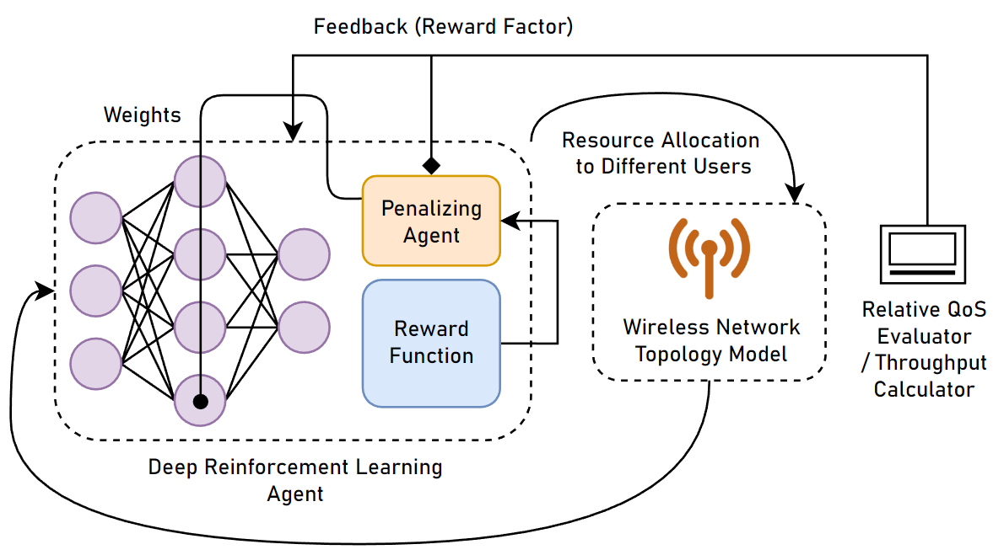

# Workflow Diagram

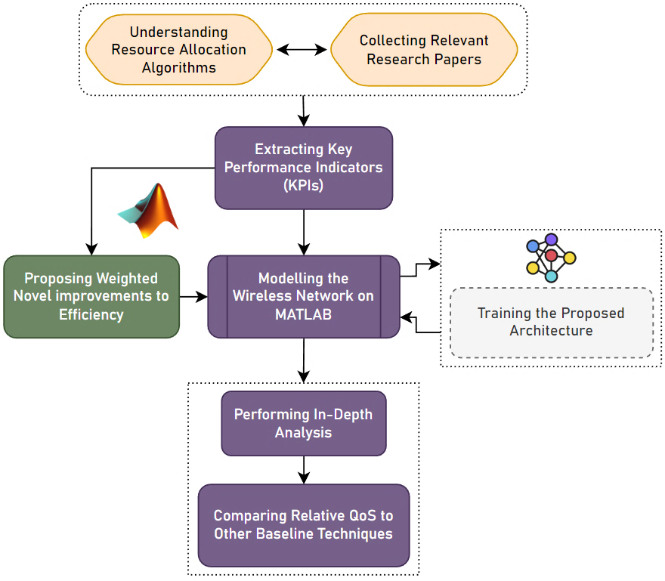

# Conclusion

By leveraging the power of reinforcement learning and neural networks, we can develop an algorithm that can dynamically allocate resources in wireless networks. This algorithm can optimize the allocation of resources such as bandwidth, power, and transmission rates to different users in the network, which can lead to better network performance and improved user experience.

We have proposed to use MATLAB to simulate the wireless network and implement the deep reinforcement learning agent. MATLAB offers a wide range of tools and functions that can make the simulation process more efficient and accurate. Moreover, the code would be made to easily modifiable and adapted to suit different network topologies and resource allocation scenarios. We believe that this project can significantly enhance our skillset as well as prepare us for the upcoming final year projects.